# Experiment conditions

The program shows the performance differences depending on the IO processing implementation. Writing and reading operations are compared, processing bytes in blocks, one by one, using buffered streams or not.

A quite decent amount of bytes (10’485’760) will be written/read using two different approaches to highlight the interest of using streams.

# Results

This is the output produced by the program on my machine, as seen in the .csv file, is resumed on the following array:

|  |  |  |  |  |
| --- | --- | --- | --- | --- |
| **operation** | **strategy** | **blockSize** | **fileSizeInBytes** | **durationInMs** |
| WRITE | BlockByBlockWithBufferedStream | 500 | 10485760 | 28 |
| WRITE | BlockByBlockWithBufferedStream | 50 | 10485760 | 32 |
| WRITE | BlockByBlockWithBufferedStream | 5 | 10485760 | 84 |
| WRITE | ByteByByteWithBufferedStream | 0 | 10485760 | 293 |
| WRITE | BlockByBlockWithoutBufferedStream | 500 | 10485760 | 77 |
| WRITE | BlockByBlockWithoutBufferedStream | 50 | 10485760 | 449 |
| WRITE | BlockByBlockWithoutBufferedStream | 5 | 10485760 | 4343 |
| WRITE | ByteByByteWithoutBufferedStream | 0 | 10485760 | 20786 |
| READ | BlockByBlockWithBufferedStream | 500 | 10485760 | 11 |
| READ | BlockByBlockWithBufferedStream | 50 | 10485760 | 20 |
| READ | BlockByBlockWithBufferedStream | 5 | 10485760 | 39 |
| READ | ByteByByteWithBufferedStream | 0 | 10485760 | 45 |
| READ | BlockByBlockWithoutBufferedStream | 500 | 10485760 | 36 |
| READ | BlockByBlockWithoutBufferedStream | 50 | 10485760 | 336 |
| READ | BlockByBlockWithoutBufferedStream | 5 | 10485760 | 3182 |
| READ | ByteByByteWithoutBufferedStream | 0 | 10485760 | 15273 |

# Modifications

In order to export the results of the program into the .csv file, 3 functions have been slightly modified. The idea is to export useful information into our .csv file. A Writer object was used.

# main()

Implementation of the Writer to be able to write into a file.

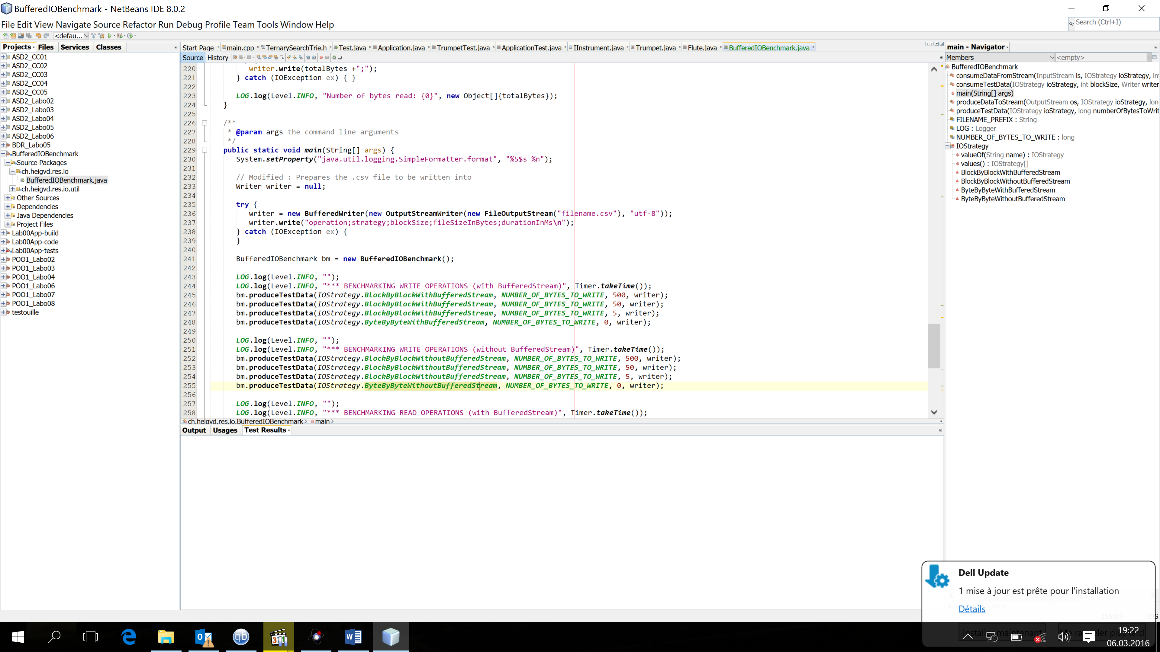

produceTestData()

Use of the writer to export useful information into our .csv file

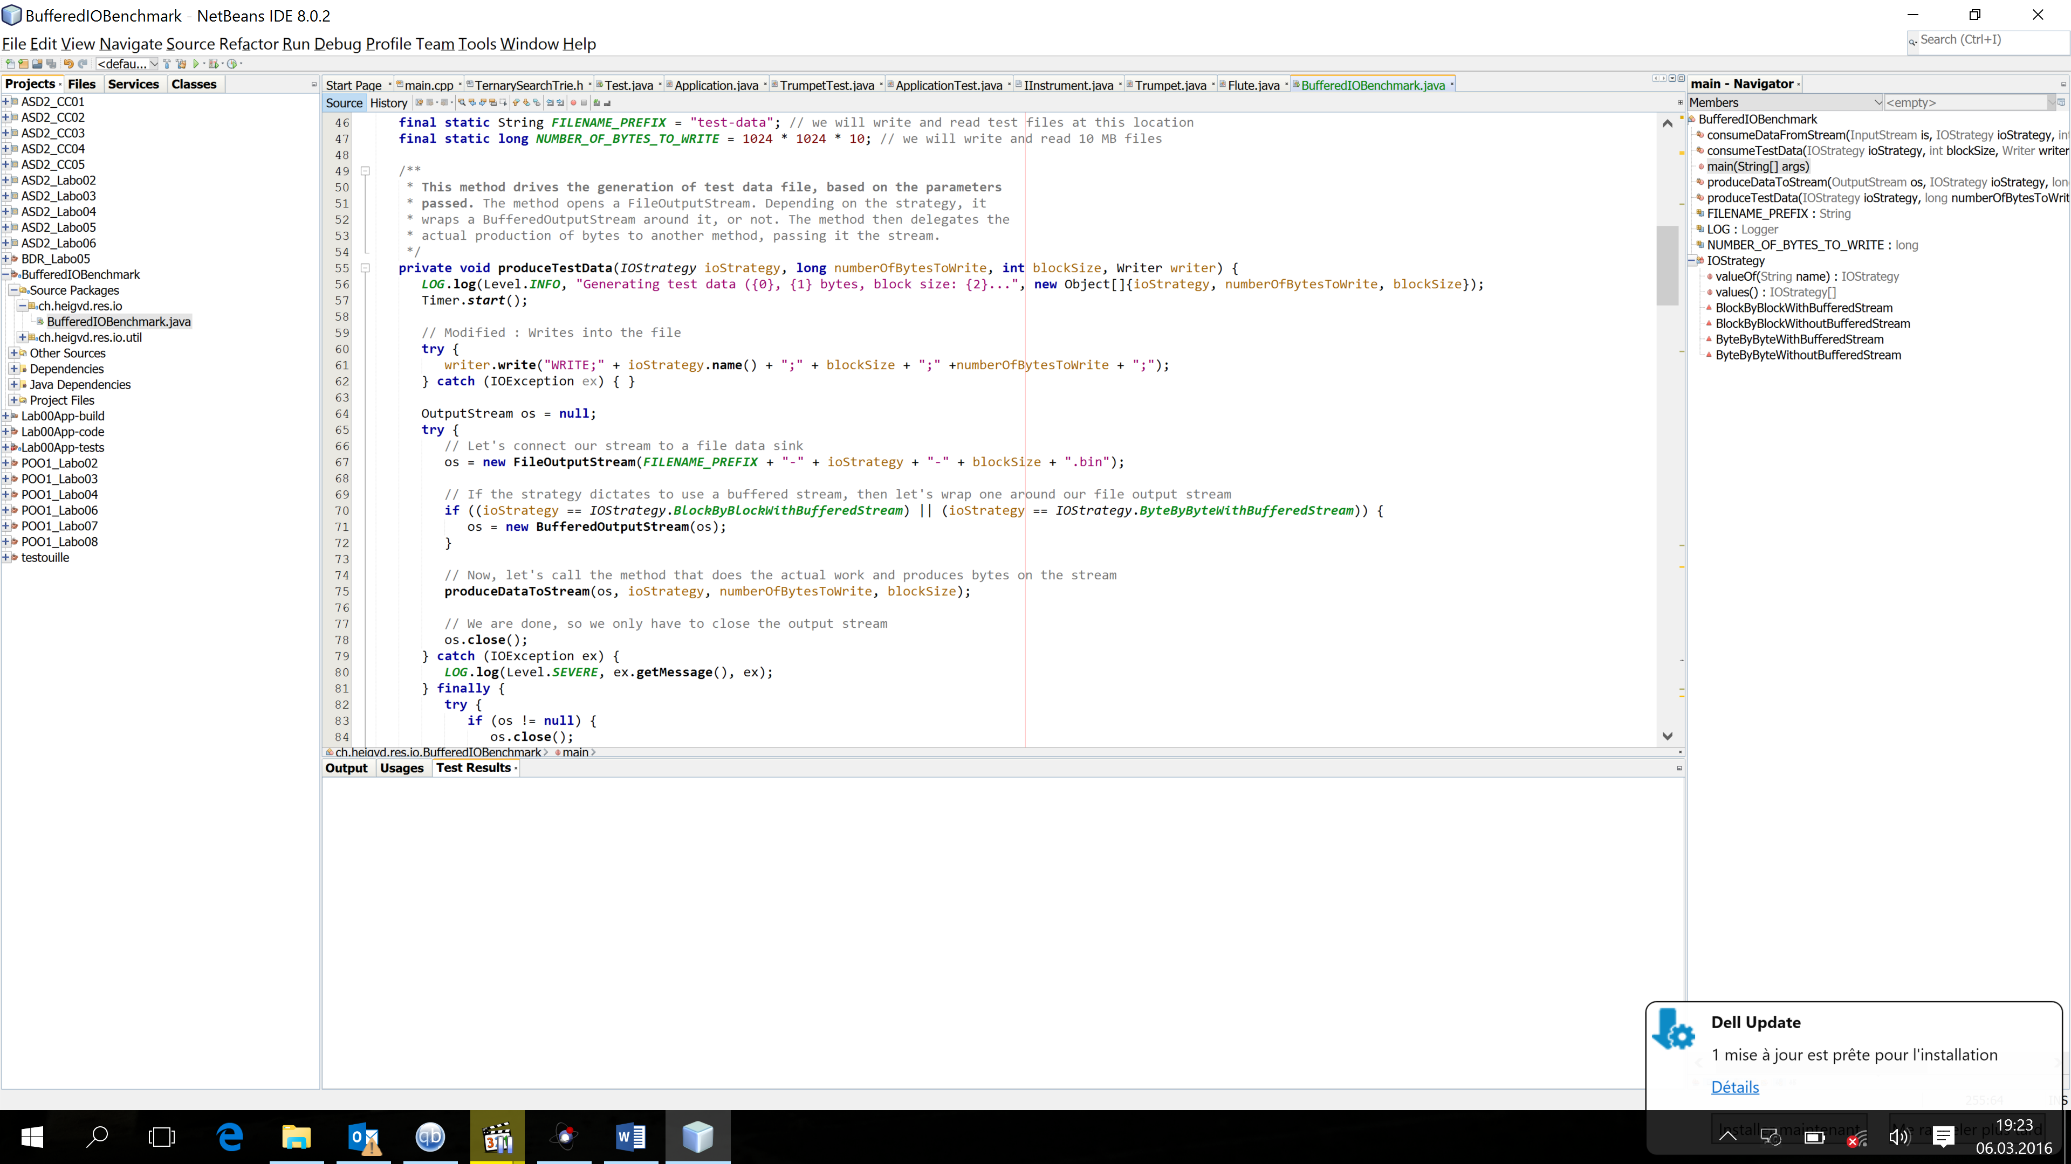

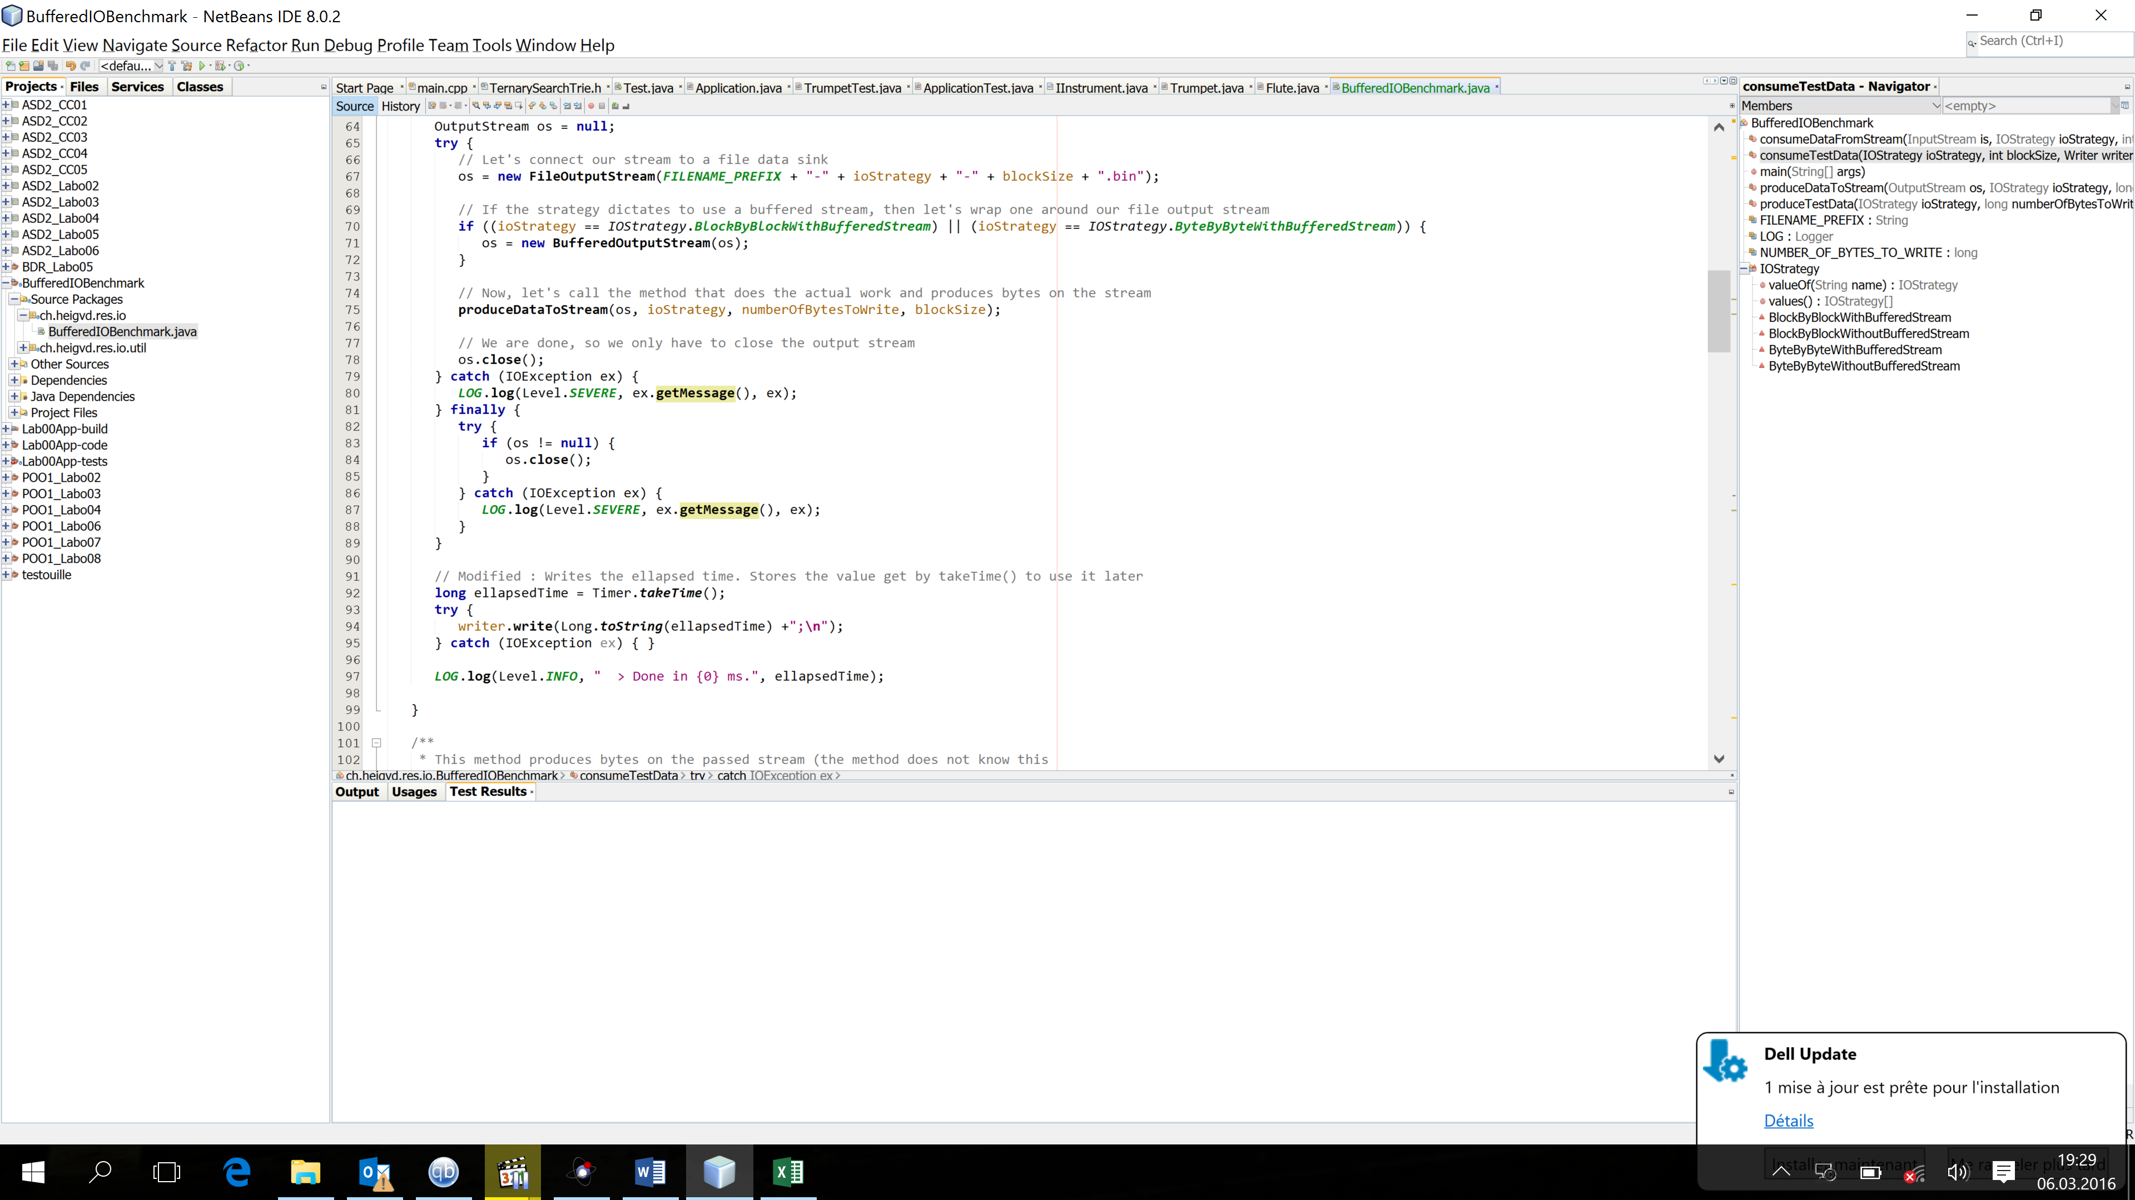

consumeTestData()

Same idea as in the produceTestData function. numberOfBytesToWrite is no longer used. Read bytes are analyzed in this case

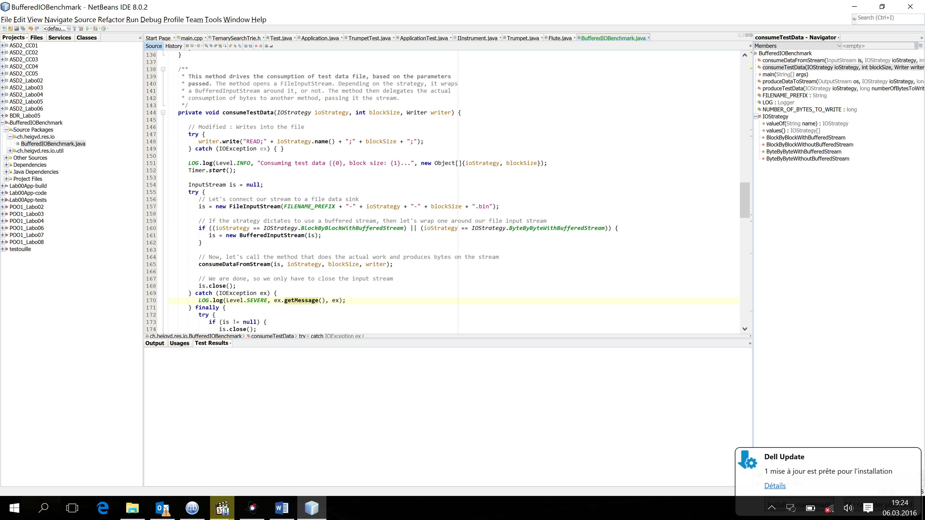

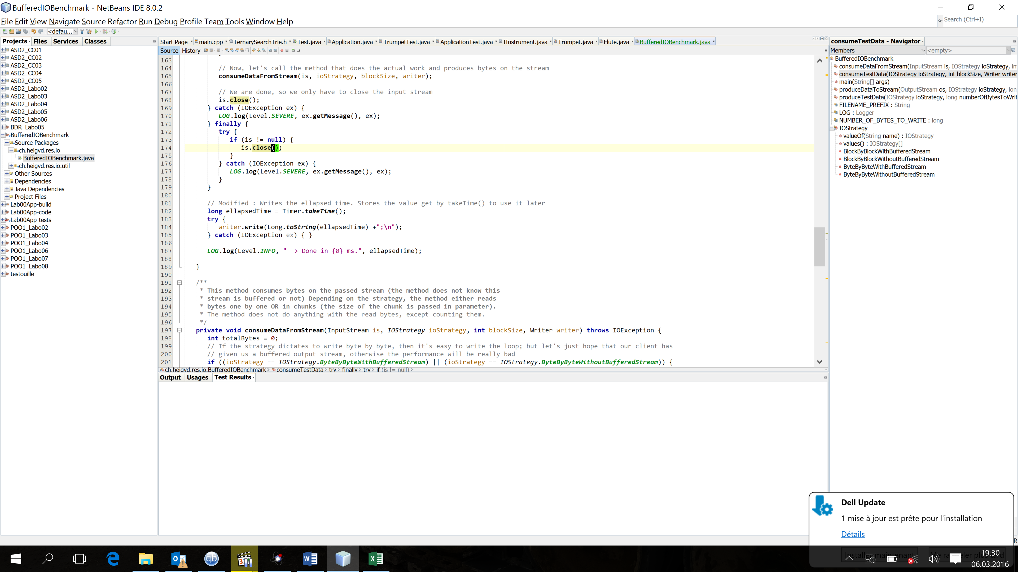

**Results analysis**

**NB**: Even if not represented on the graphics to improve readability, both functions have written/read 10’485’760 bytes.

# Comments

As seen on the graphics, a buffered stream largely improves the performances of our program. The smaller the block size, the larger the difference.

The efficiency of using a stream remains the same, using the produceTestData() (WRITE) or the consumeTestData() (READ) function.

As seen during the lesson, stream improve performance. It is much more efficient to read/write big chunks of data instead of doing it byte by byte (cf the beer example). In both cases, best running time is obtained with the largest block size (500 in our case).

The performance impact of the absence of stream can be easily be seen with smaller block size. Decreasing the block size increases by about 300% the running time using streams, and by more than 1000% without.

# Experiment conditions

Windows 10 x64, Intel I7-6700, 16 go RAM

# GitHub link

My repo can be accessed at the following address: <https://github.com/ralbasini/Exercices>/tree/master/01-BufferedIOBenchmark/BufferedIOBenchmark